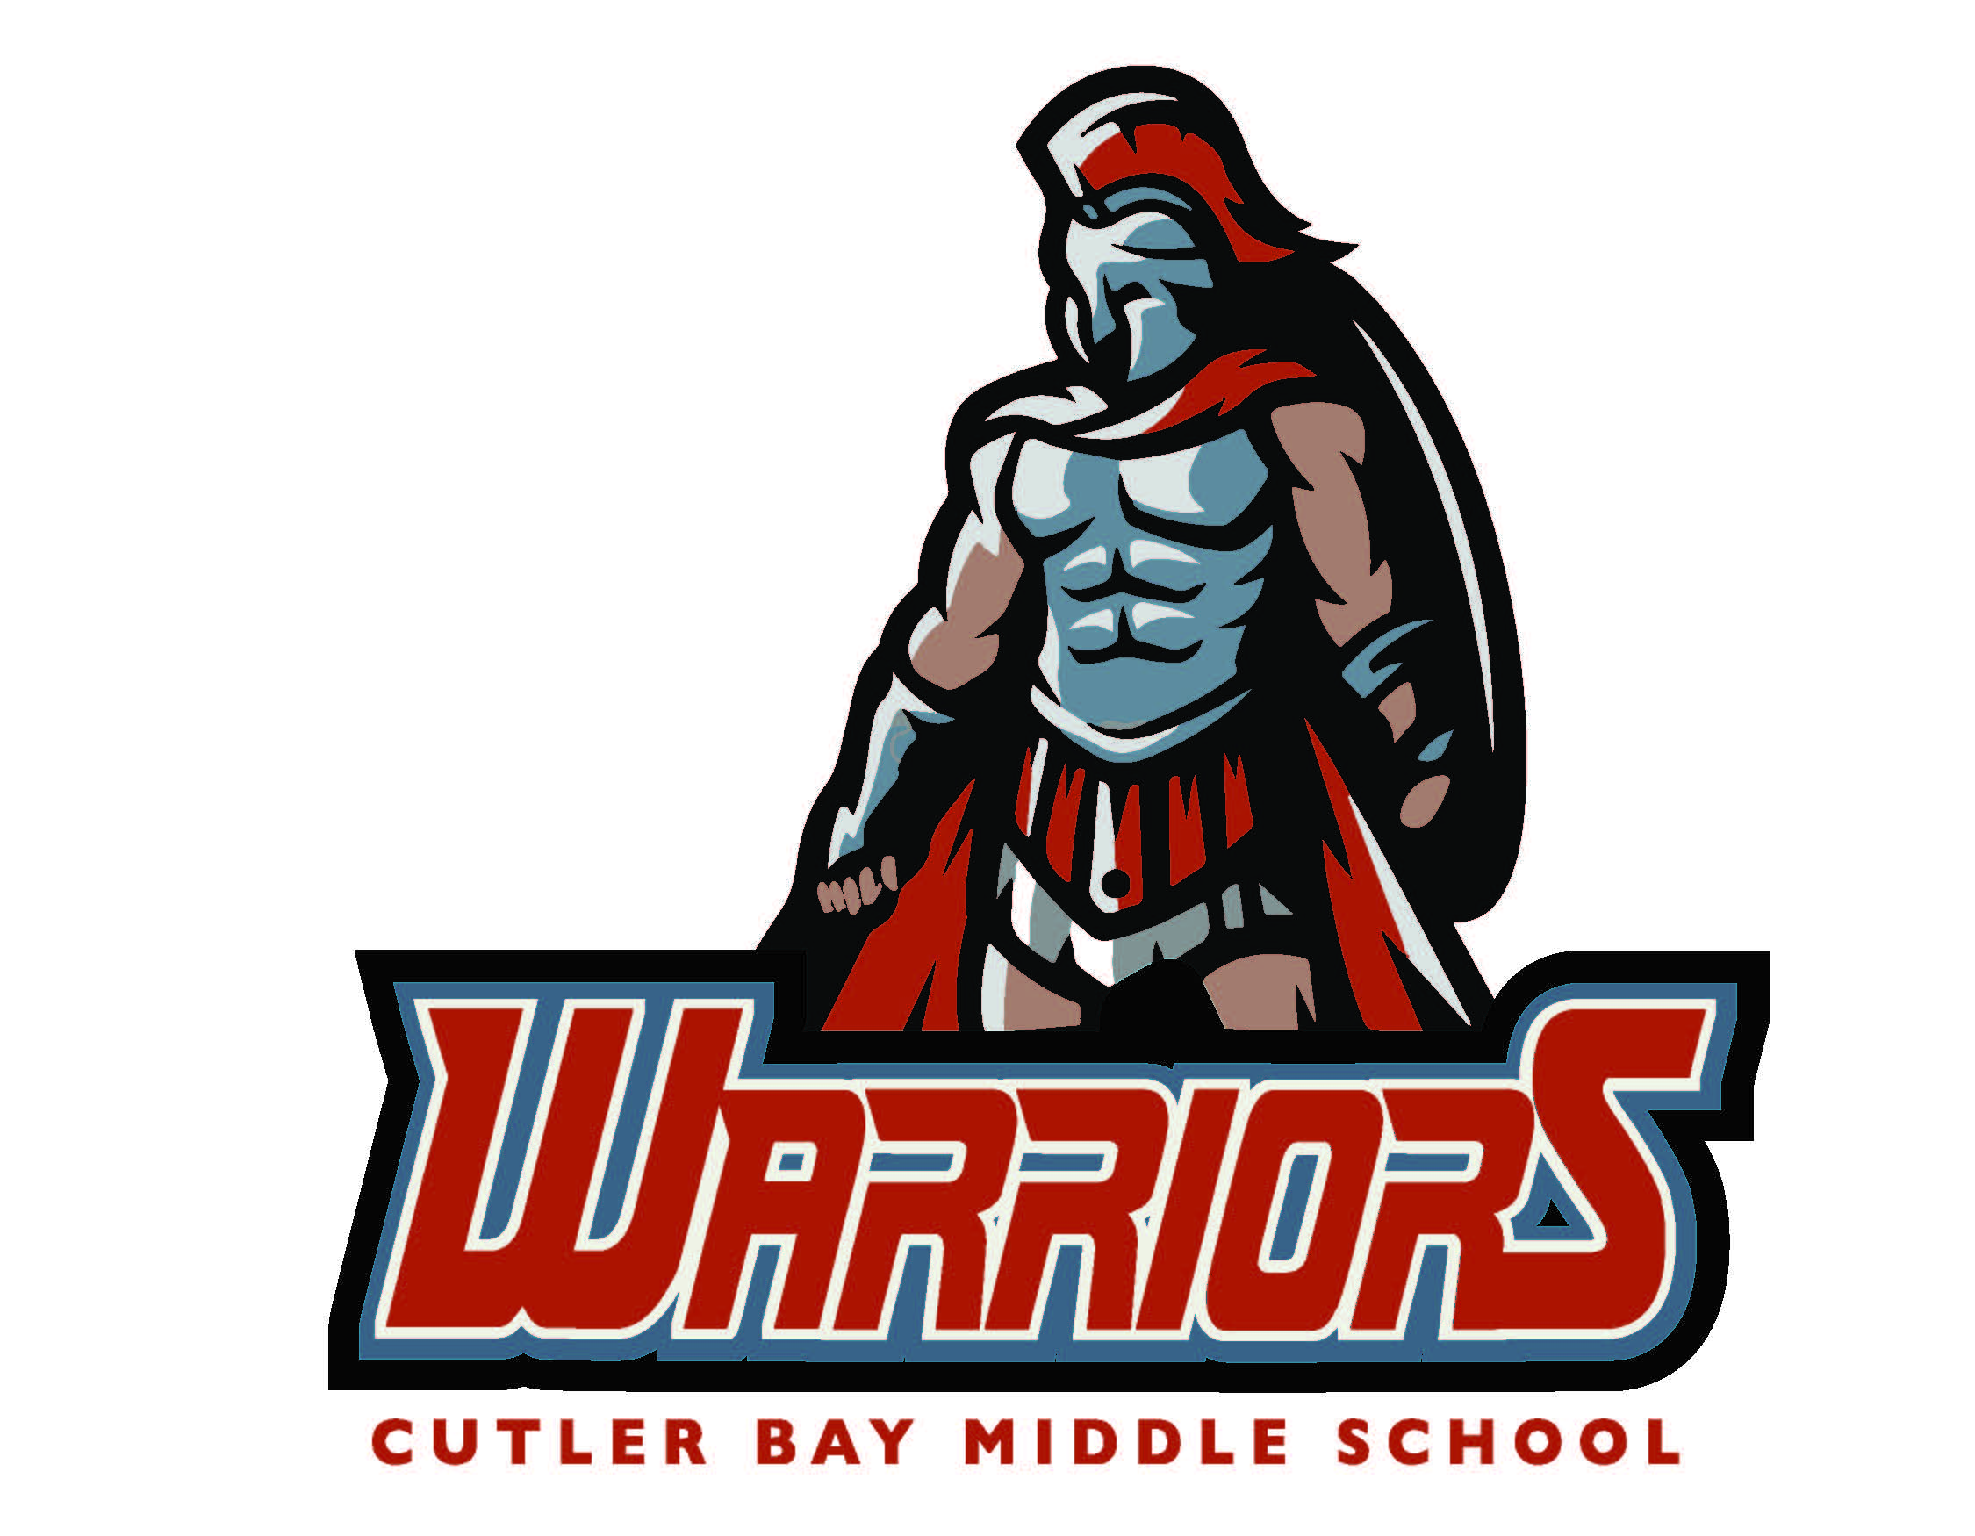

Dear Parents/Guardians,
Welcome to the 2016-2017 school year. My name is Mrs. Escobar. I teach Comprehensive Science 3.
Throughout these pages, you will find an array of information. Please take the time to go through each of them. They are a resource of invaluable information that will make this school year a successful one.
Tutoring will be available for students needing extra help. Please look for upcoming information.
Please feel free to contact me throughout the school year with questions or concerns you may have at ddescobar@dadeschools.net. I look forward to an exciting and successful school year.
Sincerely,
Mrs. Escobar

Classroom Policies & Procedures
1. No gum, food of any kind, or open beverage containers is allowed.
2. Inappropriate comments/language will not be tolerated.
3. Arrive on time to class. After three tardies to class, parent contact and conduct grade cut will be issued.
4. Raise your hand if you have a questions, comments, or concerns. Talking without permission during note taking, discussions, and exams is prohibited.
5. All assignments must be turned in on the assigned due date. No assignments will be accepted late unless you have an excused absence.
6. When moving about the room, please do so in a quiet, respectful manner.
7. Students are expected to behave appropriately during classroom and labs.
8. Bathroom passes will be provided on a need basis.
9. Students are expected to be prepared for class and participate in class discussions.
10. All Cutler bay Middle School and Student Code of Conduct rules and regulations apply.

Class Materials
- 3 Ring Binder
- 1 Pck of 5 Dividers NO POCKETS labeled as follows:
- Vocabulary
- Notes
- Classwork/Labs
- Home Learning
- Standardize Test
- Blue Ink Pen ONLY
- 1 Pck of Plastic Pocket Page Protectors
- Loose Leaf Paper Wide Rule
- 1 Pck of Multi-Color Highlighters
- Red Marking Pen
- Mini Stapler
- 3 Hole Puncher
- Scissors
- Scientific Calculator (graphing not required)
- Flash Drive Minimum 2GB

Text Book

Comprehensive Science 3 iScience Textbook/Workbook (Owl)
Physical Science Textbook

Absences
All students absent from class (unexcused or excused) are responsible for getting any missed assignments or notes.
Unexcused Absence
In the event of an unexcused absence, any missed assignments or exams will receive a "Z" as the academic grade.
Excused Absence
In the event of an excused absence, a student has 3 days to make-up any missed assignments or exams. After three days, the assignment or exam will receive a "Z".

Home Learning
All home learning assignments are to be submitted at the beginning of class on the assigned due date. No late work will be accepted.

Remind App
All students are required to download and sign up on the app Remind. This app is free and is utilized for important information. The class code will be provided on the first day of class. Parents are highly encouraged to sign up as well.

Academic Honesty

You are expected to maintain the highest standards of academic conduct. When you cheat, you are robbing yourself of knowledge, the learning experience and my company. I will be holding you to high ethical standards to which you will be expected to maintain at all times.
You are guilty of cheating whenever you present work as your own and you did not do. You are also guilty of cheating if you help someone else to cheat. Any student(s) who is discovered cheating will receive a “0” for that assignment and have the work documented in their portfolio. In addition, a conduct grade of an “F” for the present nine-weeks will be posted. A referral may be issued based on the assignment.

Grading Scale
A 100-90 4.00-3.50
B 89-80 3.49-2.50
C 79-70 2.49-1.50
D 69-60 1.49-1.00
F 59-0 0.99-0.00
Z 0x2

Assessment Percentage
Home Learning, 15%
I-Ready, &
Participation
Class Work 10% (20% Math/Reading)
Labs 10%
Quizzes /Projects 25%
Tests 35%

I have read, understood, and agree to abide by the classroom policies and procedures set forth in Mrs. Escobar’s syllabus.
______________________________________ ________
Print Student’s Name Class Period
______________________________________ ______________
Student Signature Date

Dear Parents/Guardians,

I truly look forward to working with you and your son/daughter this school year. I am very passionate about what I do, and I hope that this enthusiasm motivates my students. Please feel free to contact me at any time if you have questions or concerns. Your child also knows that he/she can meet with me before or after school if he/she has any questions that need to be addressed outside of class.

For my own records, I would greatly appreciate it if you would provide the following information so that I may be able to contact you and share any pertinent information regarding the class or your child. Thank you very much for your time!

Sincerely,
Mrs. Escobar

My child and I have reviewed and understand the expectations and policies as presented in the syllabus. We also acknowledge the availability of all class information and the syllabus online through the teacher website.

______________________________________ ______________
Parent/Guardian Signature Date

______________________________________ ___________________
Print Name Relationship to Student

How would you like to be contacted? _________________________(Home)
_________________________(Work)
_________________________(Cell)
_________________________(E-mail)
Best time to be contacted: ______________________________________

