Preparing for the First Day of School
Classroom and School Expectations
- Behavior and Consequences (In-Person/Virtual)
- Procedures/Transitions (In-Person/Virtual)
- Classroom Policies (In-Person/Virtual)
- Incentives
- Online How To’s (ZOOM, TEAMS, Submit Assignments)
- Parent Communication (Class Info/School Announcements)
Classroom Organization and Preparation
- Classroom Layout
- Décor
- Bulletin Boards-Student News, Absent Student Information, Academic Word Wall, Student Work, Student Data, Motivational/Inspirational, Anchor Charts, Multicultural)
- Classroom Labels (ESOL Students)
- Copies of IEP
- Common Board
- Data Binder
- Teacher Office Supplies (pens, pencils, copy paper, paper protectors, tabs, planner, calendar, post-it, note pad, highlighter, sharpie, dry eraser marker kit, pencil sharpener, calculator, flash drive, file folder, paper clips, staples, stapler, tape, tape dispenser, trash can, extra batteries)
- Student Passes
- Computer (Teacher and Student)
- iPad (Teacher and Student)
- Printer (Teacher)
- Smart Board
- Overhead Projector
- Remotes
- Bell Schedule
- ESOL Dictionaries
Instructional
- Teacher website
- Prepare Course Syllabus
- “Get to Know Teacher”
- Parent Contact Form (Communication On-Line)
- Student Interest and Learning Style survey
- Textbooks (hard copy and online access)
- Teacher edition (hard copy and online access)
- Online Curriculum Platform Log-in Information
- Student Folders
- Student Data Folders
- Communication Log
- Student Rosters
- Fire Drill Folder
- Subfolder
- Copies
- Seating Chart
- Lesson Plans for first 2 weeks
- Pacing Guides
- Testing Calendar (State and District)
- ALD’s (Achievement Level Descriptors)
- Item Specs

First Day of School Countdown Checklist

3 weeks before:
- Get your doctors’ appointments out of the way! (you, your family, pet, etc.)
- Take advantage of back to school sales for supplies, clothes, and watch out for tax-free shopping. These usually start in August. Ask for teacher discounts!
- Look out for your teacher bag, briefcase, etc. that you are going to use for the year. It should store your personal items like cellphone, wallet, tablet, and large enough to put a book and files in it.

2 weeks before:

- Get your new school calendar (either hardcopy and/or on your tablet/phone) ready by marking birthdays, field trips, back to school night, holidays, teacher workdays, early releases, end of the grading period, etc.
- If you have not visited your school yet because it is your first year there, make the drive to see how long it takes you to get there. The secretaries, counselors, and administrators at many middle and high schools start working a few weeks before teachers are expected to report to school. Introduce yourself.

1 week before:

- Get to school one day before teachers are expected to report.
- Submit your rules and opening of school worksheets to copy. Avoid having to pay for all those copies yourself by beating the rush (especially if you are teaching in a large school).
- Start bringing your materials from home, organizing your classroom, putting up your bulletin boards and/or relocating to your new classroom
- Your school by now should already have the agenda for the teacher workdays as far as meetings, trainings, etc. that you are expected to attend. Highlight those and mark them on your calendar.
- Organize your teacher’s desk and classroom. Set up your class stations, word walls, put up posters, and check that your pencil sharpener, clock, TV, and PA system are all working.
- Attend all faculty, club, coach, and department meetings you are a part of. Jot down any changes to school policies that you must inform your students on the first day

One day before:

- Your board should have your name, the date, agenda, and a warm welcome message for your students
- On your desk you should have all your copies of your class rules, syllabus, notebook checklist, student inventory, and other necessary first day of school forms organized in the order you will be distributing them.
- Make sure you have set up your website, blog, etc. with a welcome message for both parents and students and post the HW for the first day of school in advance
- Get some rest the night before (although it is normal to have the first day jitters) and bring a positive attitude for your first day.

Classroom Procedures & Policies Checklist
General Classroom Procedures
□ Getting & acknowledging attention
□ Posting class announcements
□ Posting daily schedule
□ Posting homework
□ Conducting drills
Policies
□ Classroom discipline plan
□ Distance Learning
□ Grading scale and system
□ Late work
□ Absences
□ Heading Papers
□ When students may be out of their seats
□ When students may approach your desk
□ When students may use the pencil sharpener
□ When students may use the restroom
□ When students may use the water fountain for drinks
□ Borrowing supplies from the teacher
□ Handling teacher’s property
□ Caring for school property
During Class
□ Entering classroom
□ Taking attendance
□ Completing bell work
□ Announcements
□ Collecting homework (where, when)
□ Getting out supplies
□ Passing out materials
□ Heading papers
□ Behaving during teacher instruction time
□ Requesting help
□ Completing independent seat work
□ Transitioning from independent seat work to small group work
□ Transitioning from small group to independent seat work
□ Working in pairs
□ Working in cooperative groups
□ Participating in class discussion
□ Finishing early
□ Not finishing work
□ Taking tests
□ Collecting papers/classwork
□ Cleaning up workspace
□ Handling classroom interruptions (i.e. phone calls, unexpected visitors)
□ Behaving with guest
□ Behaving with substitutes
Student organization
□ Using an agenda or planner
□ Keeping desks tidy
□ Keeping Classroom tidy
Technology in the Classroom
□ Using class computers (rules and schedule)
□ Using class audio and visual equipment (rules and schedule)
□ Using iPad
□ Digital Citizenship

Leaving the Room
□ Preparing for class switches
□ Lining up to leave the room
Outside of the Classroom
□ Walking in the hallways
Breaks
□ Taking restroom/water breaks
□ Going to lunch
End-of-the-Day
□ Cleaning up
□ Being picked up by a parent
□ Dismissing for busses

Common Board Configuration
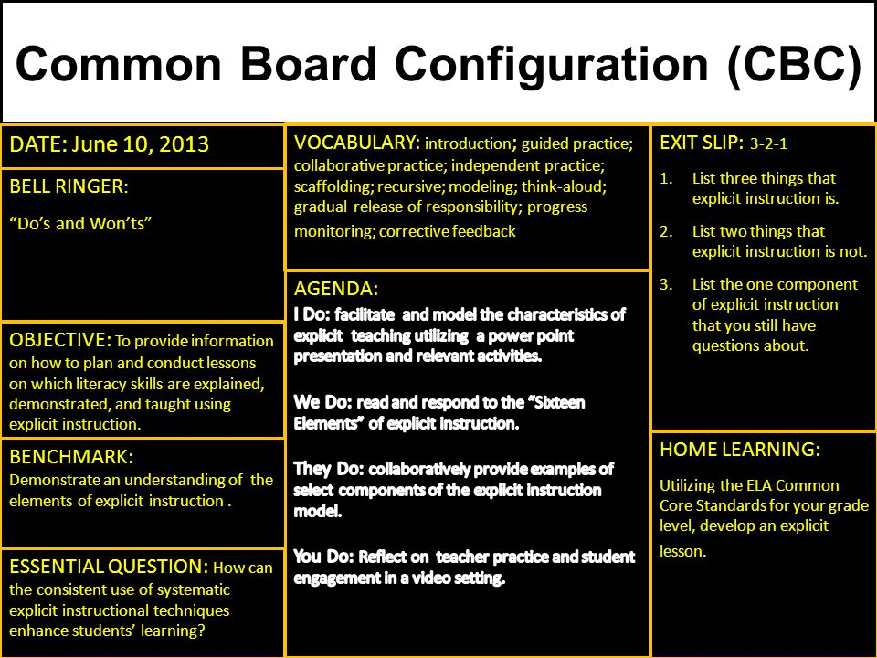

Data Binder
Organized quarterly with Most Recent on Top
- Pacing Guide
- IFC (Instructional Focus Calendar)
- Lesson Plans
- Student Data
  - iReady AP1,2,3
  - Instructional Groupings
  - Growth Monitoring
  - Topic Assessment
  - Baseline/MYA
- ESOL/IEP
- Grade Verification
- Parent Communication Log

